CIRRASPEC Ashion Site  
User’s Manual

System Version: 3.0

Revision History

|  |  |  |  |
| --- | --- | --- | --- |
| **Document Version** | **Date** | **Name** | **Description** |
| 1.0 | 2/15/2018 | Sayali Dev | User Manual Created for Ashion Speciality Lab User |

**Table of Contents**

Revision History 2

Accessing the Application 4

Login Guidelines 4

Logging into the Application 4

Logging off the Application 5

Accessing the Home Page 6

Accessing the My Account Page 7

To set user profiles on My Account page 8

Site Settings 8

Changing Your Password 8

Navigating through the application 9

Workflow for Biobank Research Technician – At Ashion 12

Receive specimen shipment for patients test ordered 13

Viewing the Shipment Search Page 13

Searching for a Shipment 14

Viewing Shipment Details 16

Receiving a Biospecimens Shipment 18

Check in specimens in shipment and Store specimens in the inventory 20

Checking in and Store Biospecimen in inventory 20

Checking in and Store Biospecimens in Bulk 26

Upload the lab report into the system to the patient enrolled 35

Viewing a list of Subjects 35

Searching for a Subject 36

Viewing the Subject Details 38

Upload patient test report into the system 39

Understand Search Options and Search Results Display Options 41

Search by Date Ranges 41

Change Search Results display 43

Changing the Number of Records Per Page 43

Changing the Display Columns 44

Sorting Search Results 45

# 

# Accessing the Application

To access the CIRRASPEC application, you must have a valid user name and password.

### Login Guidelines

* The password must contain a minimum of six characters and is case sensitive.
* The password must contain at least one alphabet, one number and one special character such as !, @, #, &, etc.
* The application prompts you to change your password after you login for the first time. For more information about how to change your password, see **Changing Your Password**.
* This application supports the following browsers:
  + Firefox 3.5 and above
  + IE 8.0 and above
* You must not run IE 8.0 in the Compatibility mode. You can check the IE compatibility view by clicking **Tools** > **Compatibility View settings**.
* You must ensure that any pop-up blocker software is turned off.

## Logging into the Application

To log in:

1. Enter CIRRASPEC web site URL In the address bar of a Web browser.

The **Login** page appears.

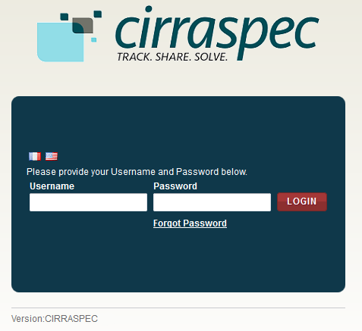

1. In the **Username** box, type your username and in the **Password** box, type your password.

**Note:**

If you have forgotten your login credentials or need login assistance, send an e-mail to [cirraspec@tgen.org](mailto:Bio4Dhelp@tgen.org).

1. Click **Login**.

The CIRRASPEC **home page** appears.

On top right, below the My Account link, Home page displays Welcome note:“Welcome User Sitename”

**Note:**

* If you have more than one assigned collection site locations, you are prompted to select the appropriate location for this Web session.
* Click on **SAVE,** the home page displays the location selected on top right Welcome note.

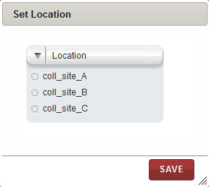

## Logging off the Application

To log off from the application, in the upper-right corner of any page, click the **Logout** link.

On successful logout, The **Login** page appears.

## Accessing the Home Page

You can access the CIRRASPEC home page from any other page by clicking the **Home** tab.

1. Allows you to access the CIRRASPEC home page
2. Allows you to access your account for password and user profile maintenance
3. Welcome note displaying user logging to the site
4. Allows you to log off from the application.
5. Easy Access Links

2

4

3

1

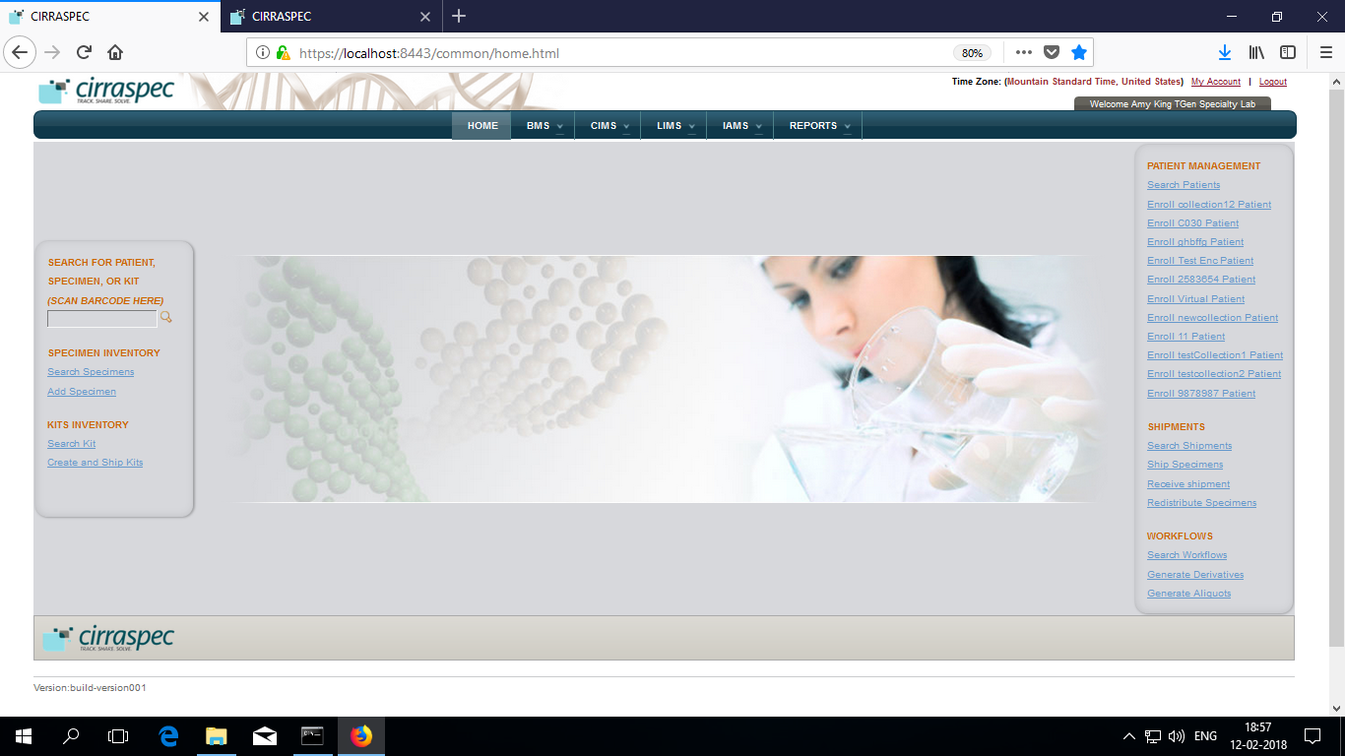

5

5

## Accessing the My Account Page

You can use the My Account page to update your user profile (language and location preferences) and your login password.

To access the **My Account** page:

1. In the upper-right corner of any page, click the **My Account** link.

The **My Account** page appears.

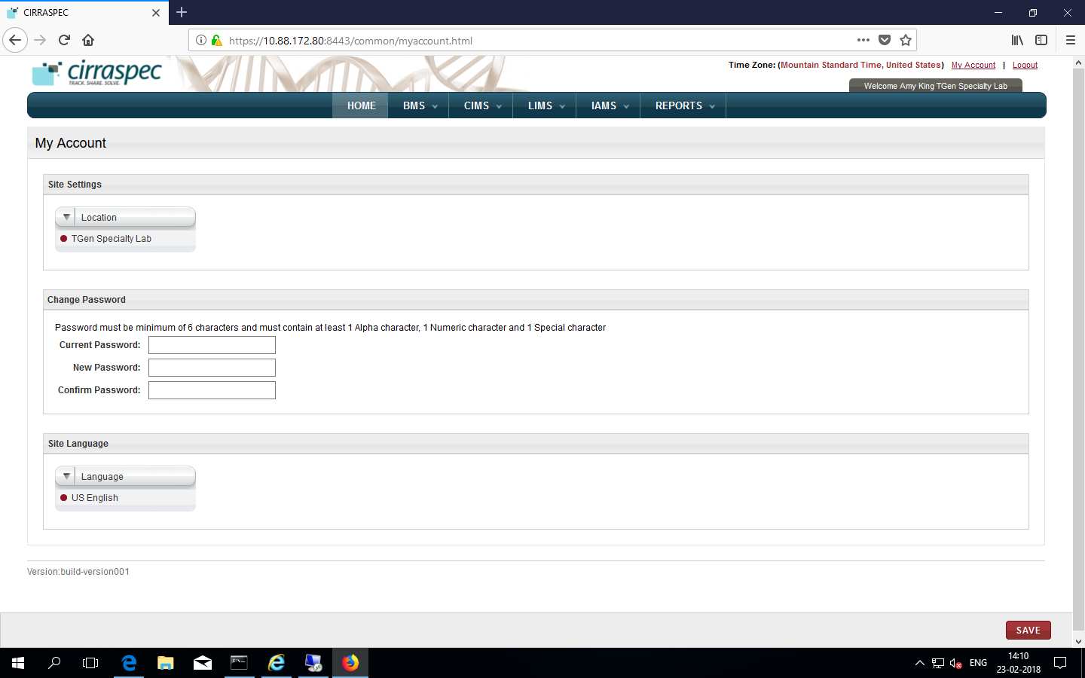

### 

### To set user profiles on My Account page

### Site Settings

Allows you to select a different collection site location to view information and perform tasks associated with that location.

To select a different location:

1. Click on the **Location** list dropdown arrow.

Locations list displays all locations assigned to you based on your user role and access permissions.

1. Select the desired location.
2. Click **SAVE**.

The location is updated. Information associated with that location is displayed on the CIRRASPEC pages.

### Changing Your Password

Allows you to update the password for login to Cirraspec application.

Password Guidelines:

* The password must contain a minimum of six characters and is case sensitive.
* The password must contain at least one alphabet, one number and one special character such as !, @, #, &, etc.

To change your password:

1. In the **Current Password** boxof the **Change Password** area, type your current password.
2. In the **New Password** box, type a new password.
3. In the **Confirm Password** box, type the new password again.
4. Click **SAVE**.  
   Your password is changed.

**Note:** For assistance with the username or password, send an email to [cirraspec@tgen.org](mailto:Bio4Dhelp@tgen.org)

# 

# Navigating through the application

**NOTE**:

You can scan barcode for the specimen /kit to enter source identifiers into the application.

**You can Search for Patient, Kit, Specimen using their barcodes.**

To search by barcodes:

* + 1. Scan or enter the barcode
    2. Click on Search icon

BMS tab:

|  |  |  |
| --- | --- | --- |
| Tab | Function | Events: |
| Bulk Modifications | Allows to search and perform activities on batches or on group of biospecimens. | Assigning Storage Locations, modifying biospecimens, uploading files, adding events, generating labels |
| Inventory | Allows to search for biospecimens, view biospecimen details and modify theinventory records.  Allows to create inventory. | View, print label, modify information, complete form, generate report, add to worklist, delete biospecimens |
| Kits Inventory | Allows to perform kit related activities. | Search kits, modify kit contents, generate reports, print labels, download forms. |
| Kits Shipment | Allows to receive kits shipments | Receive Shipments, Check the Biospecimens into inventory |
| Shipments | Allows to ship kits from collection site to biobank sites. | Create kits shipment, send shipment,  Modify/delete kits shipments |
| Worklists | Allows you to create and work on a group of biospecimens as a worklist | Define, search worklists, update information, generate labels |

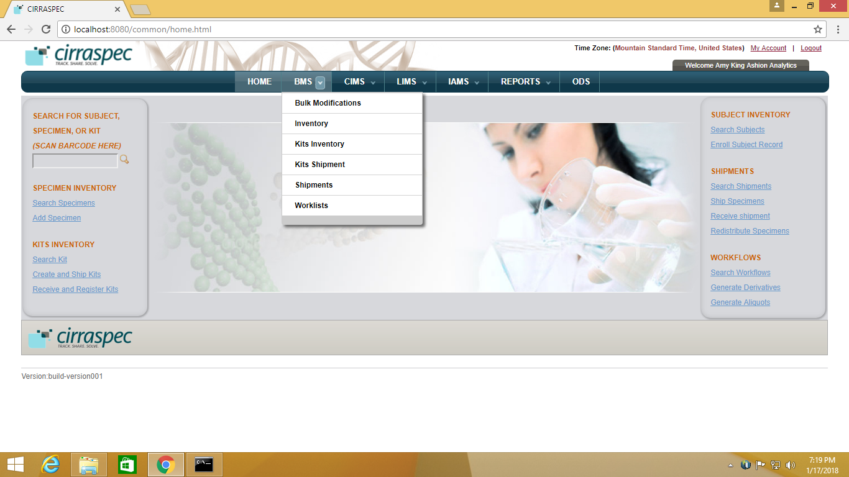

CIMS tab:

|  |  |  |
| --- | --- | --- |
| Tab | Function | Events |
| Subject Centric View | Allows subject /donor / patient mangement | Update forms, assign kits to collection events, collect subject specimens, download reports. |

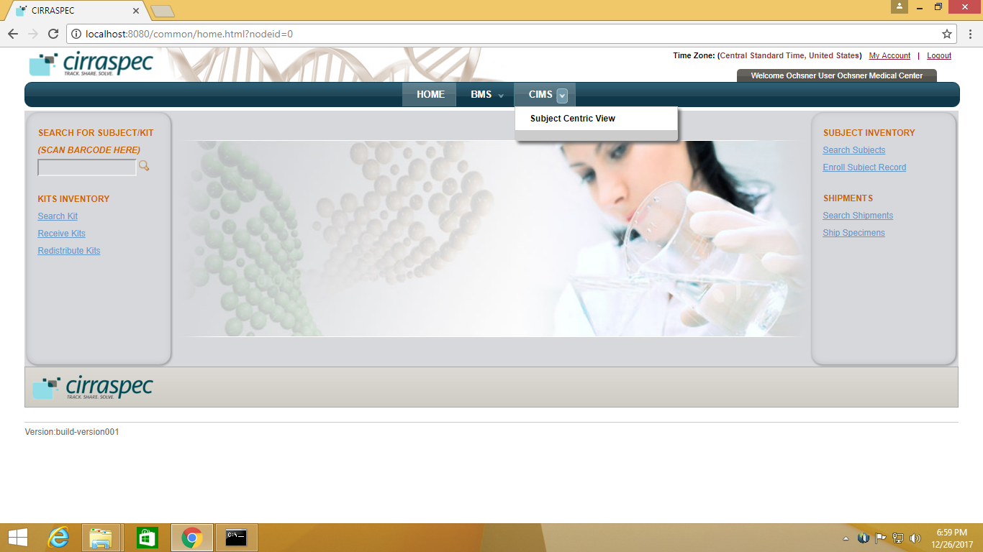

LIMS tab:

|  |  |  |
| --- | --- | --- |
| Tab | Function | Events |
| Workflows | Allwos to create sample processing workflows | Create workflows, View and Modify Workflows, Manage Workflows |



IAMS tab:

|  |  |  |
| --- | --- | --- |
| Tab | Function | Events |
| Import Data | Allows to import data by uploading a pre-defined spreadsheet templates | Process Template Upload, Inventory Bulk Upload template, Kit Creation / Shipment template  Batch Specimen Shipment template  Create Subjects template upload, Create Forms template upload, LIMS Workflow Upload template |



Reports Tab:

|  |  |  |
| --- | --- | --- |
| Tab | Function | Events |
| Reports | Allows you to view reports | View Specimen report, View Inventory report |



# Workflow for Biobank Research Technician – At Ashion

Receive specimen shipment sent by COH for patients test ordered on page 13

Check in specimens in shipment and Store specimens in the inventory on page 20

Upload the report into the system to the patient enrolled on page 37

Understand Search Options and Search Results Display Options on page 45















































# Receive specimen shipment for patients test ordered

### 

### Viewing the Shipment Search Page

To view a list of shipments:

1. Log in to the application using your log in credentials.  
   **Note:** If you have more than one assigned location, you are prompted to select the location for which you want to access CIRRASPEC data.
2. Point to the arrow of the **BMS** tab, and then click **Shipments**.   
   The **Shipment Search** page appears.
3. Click **SEARCH**.  
   The shipment search page displays a list of shipments that are accessible based on your login location.

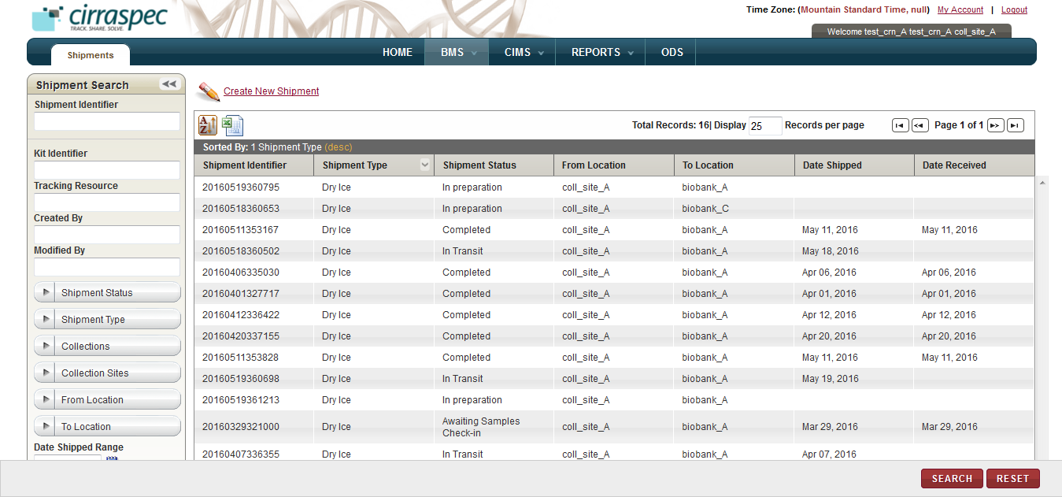

For information about how to sort the shipments list, change the column display and/or the number of records per page, see **Changing Search Results Display**

### Searching for a Shipment

To search for a specific shipment or a group of shipments:

1. Point to the arrow of the **BMS** tab, and then click **Shipments**.   
   The **Shipment Search** page appears.

The search results list displays all shipments that are accessible based on your login location.

Arrow hides/displays

the Shipment Search pane



1. Specify your search criteria by completing one or more fields in the **Shipment Search** pane.

**Note:**

* You can use one field or a combination of fields to search for a shipment.
* You can type the full or partial value in a search field along with an asterisk (*) before or after the partial value. For example, if you type **02\***, you obtain records that begin with 02. If you type **\*02**, you obtain records that end with 02.

Following table lists each search field and its description.

Table : Shipment Search Fields

| **Field** | **Description** |
| --- | --- |
| **Shipment Identifier** | Type or scan identifier of the shipment that you want to search for. |
| **Kit Identifier** | Type or scan identifier of the kit that you want to search for. |
| **Tracking Resource** | Type the courier’s tracking number to search for shipments associated with that tracking number. |
| **Created By** | Type the log in ID of the user to search for shipments created by that user. |
| **Modified By** | Type the log in ID of the user to search for shipments modified by that user. |
| **Shipment Status** | Click appropriate shipment status to search for shipments with this status.  **Note:** To search for shipments with any status, click **All**. |
| **Shipment Type** | Click appropriate shipment type to search for shipments of this type.  **Note:** To search for shipments with any status, click **All**. |
| **Collections** | Click appropriate Collection to search for shipments associated with this Collection.  **Note:** To search for shipments associated with all Collections, click **All**. |
| **Collections Sites** | Click appropriate Collection Site to search for shipments associated with this Collection Site.  **Note:** To search for shipments associated with all Collection Sites, click **All**. |
| **From Location** | Click appropriate location to search for shipments sent from this location. |
| **To Location** | Click appropriate location to search for shipments sent to this location. |
| **Date Shipped Range** | Click the date icon and then in the pop-up, select appropriate date option to search for shipments shipped in this timeframe. For more information, see **Understanding the Date Range Options** |
| **Date Received Range** | Click the date icon and then in the pop-up, select appropriate date option to search for shipments received in this timeframe. For more information, see **Understanding the Date Range Options** |

1. Click **SEARCH**.  
   The search results list displays all shipments as per the search criteria entered.  
     
   **Note:** Click the header of the column with which you want to sort the results. For more information about how to sort the search results, see **Sorting Search Results**



### 



### Viewing Shipment Details

To view a shipment:

1. Log in to the application using your log in credentials.

**Note:** If you have more than one assigned location, you are prompted to select the location for which you want to access CIRRASPEC data.  
The CIRRASPEC home page appears.

2. Point to the arrow of the **BMS** tab, and then click **Shipments**.

The **Shipment Search** page appears.

1. Click **SEARCH**.

The shipment search page displays a list of shipments that are accessible based on your login location.

1. Click the row of the shipment for which you want to view the details.

The **View Shipment** page appears.

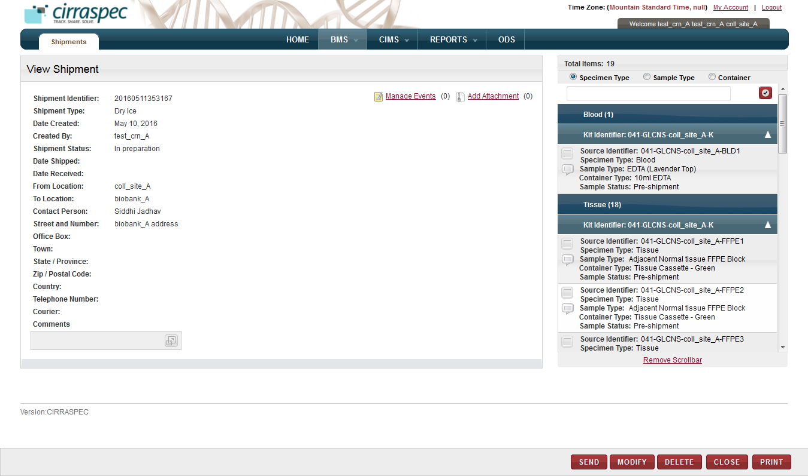

On the **View Shipment** page, you can initiate the following tasks :

* **Receive biospecimens Shipment:**

You can receive biospecimens shipment sent from the collection site. For more information, see

**Receiving a Biospecimens Shipment**

* **Check In Biospecimens – Store Biospecimens in the inventory:**

You can check in shipment biospecimens in part or completely. For more information, see

**Checking In a Biospecimens Shipment**.

Also you can perform :

### Receiving a Biospecimens Shipment

### 



**Note:** The shipments with **In Transit** status can be received:

To receive a biospecimens shipment:

1. Log in to the application using your log in credentials.

The home page appears.

1. Point to the arrow of the **BMS** tab, and then click **Shipments**.

The **Shipment Search** page appears.

1. Click **SEARCH**.

The shipment search page displays a list of shipments that are accessible based on your login location.

1. Click the row of the shipment that you want to receive.

The **View Shipment** page appears.

1. Click **Receive**.   
   The **Receive Shipment** page appears.

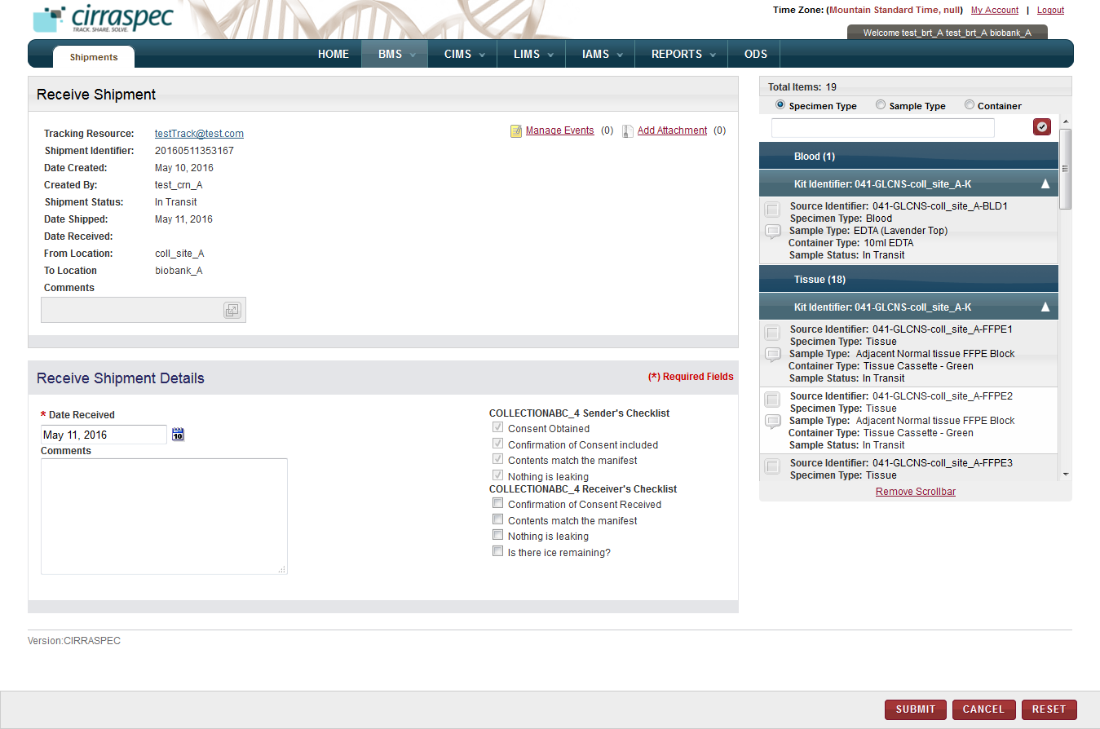

1. In the **Receive Shipment Details** area, enter appropriate information in each field. Following table lists each field and its description.

**Note:** Fields that are marked with the red asterisk (*) are mandatory.

Table : Receiving a biospecimen shipment

| **Field** | **Description** |
| --- | --- |
| **Date Received**\* | Click the date icon Search calendar, and then click the date when you received the shipment.  The date appears in the **Date Received** box. |
| **Comments** | Type |
| **Receiver’s Checklist** | Select the checkboxes from this list and ensure that the respective actions have been taken.  **Note**: If user does not select any or all of the checkboxes, a message box reading “Receivers checklist is not complete. Do you still want to continue?” is shown. If you need to proceed without selecting these checkboxes, click the OK button. |

1. To add an event to this shipment, click the **Manage Events** link.   
   The **Manage Events** window appears.  
   **Note:** For more information about how to add an event, see **Managing Events**.

1. To attach a file to this shipment, click the **Add Attachment** link.   
   The **Manage Attachments** window appears.  
   **Note:** For more information about how to attach a file, see **Common File Upload**.
2. Click **SUBMIT**.

On the **View Shipment** page:

The shipment status changes to **Awaiting Samples Check-in** and the status for all biospecimens in the shipment cart appears as **In Transit** .

*Alternative Path:*

* On Home Page, click on “Receive Shipments” link.

The The **Shipment Search** page appears.

Follow same steps as above from step3 to receive shipment.

# Check in specimens in shipment and Store specimens in the inventory

### Checking in and Store Biospecimen in inventory

**Note:**

* The shipment must have the **Awaiting Samples Check-in** status.
* The shipment status does not change to **Completed** until all the biospecimens associated with this shipment are checked in

To check in a shipment biospecimen:

1. Log in to the application using your log in credentials.

The home page appears.

1. Point to the arrow of the **BMS** tab, and then click **Shipments**.

The **Shipment Search** page appears.

1. Click **SEARCH**.

The shipment search page displays a list of shipments that are accessible based on your login location.

1. Click the row of the shipment for which you want to check in biospecimens.

The **View Shipment** page appears.

1. Click **CHECK IN SAMPLES**.

The **Check-in-Sample** page appears.

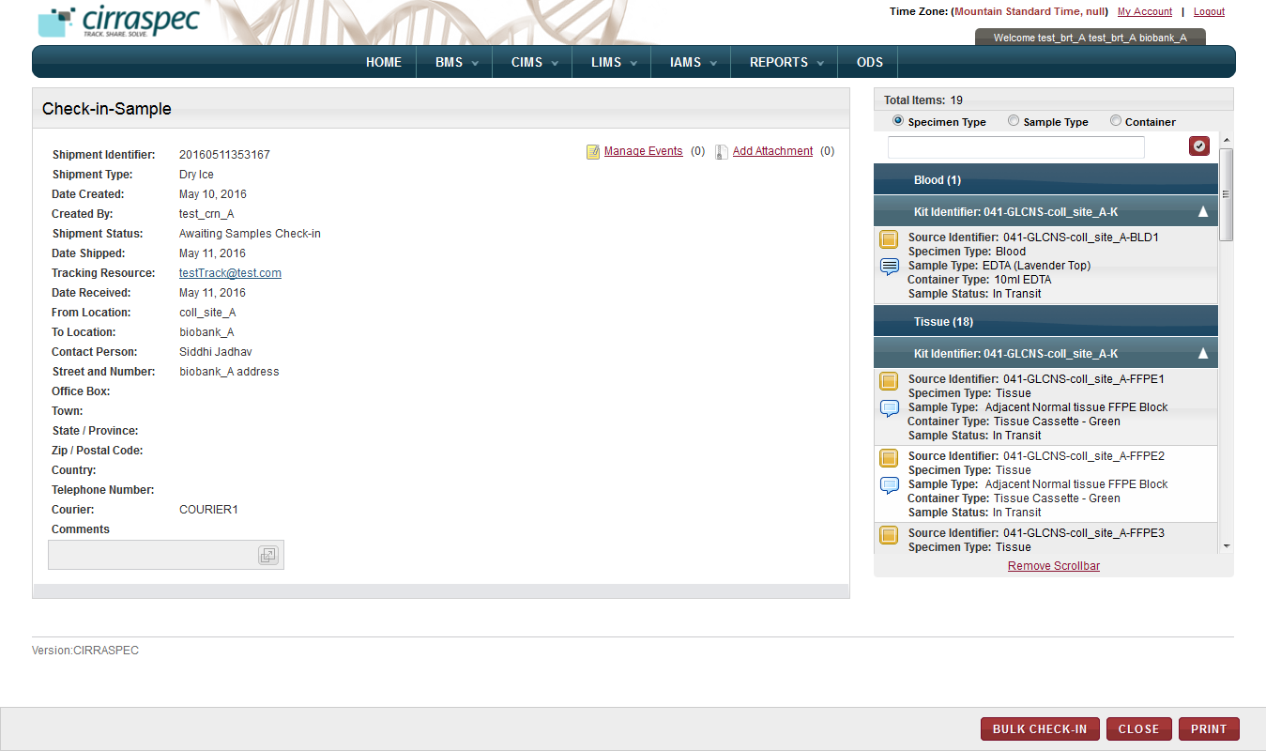

1. In the shipping cart, Click the yellow box against the biospecimen that you want to check in.

**Note:**

* Biospecimens that are not checked in are marked with a yellow box.
* Biospecimens that are checked in are marked with a blue check mark box.
* You can sort biospecimens by clicking the appropriate type under **Total Items**.
* To search for a biospecimen, in the box under **Total Items**, type the appropriate shipment or biospecimen identifier, and then click the check mark icon check mark icon.

The **Sample** window appears.

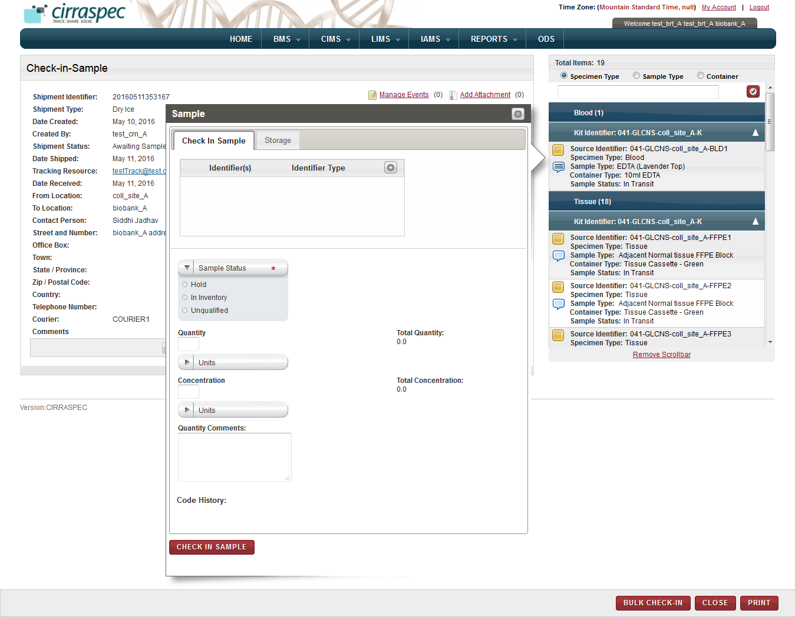

1. Sample window
2. On the **Check In** **Sample** tab, enter appropriate information in each field.   
   Following table lists each field and its description.

Table : Checking in a biospecimen

| **Field** | **Description** |
| --- | --- |
| **Identifier(s)** | If you want to add a new identifier for this biospecimen:   1. Click on the add icon add icon. 2. In the **Source Identifier** box, type the new identifier. 3. In the **Identifier Type** list, click the appropriate identifier type.  **Note:** The **Identifier Type** list displays the following identifier types:  * **Internal:** For user-assigned identifiers based on lab or site naming or numbering conventions. * **Kit Content:** For identifying the biospecimen contained within a kit. * **Other:** For any other identifier type.  1. Click the check mark icon check mark icon.   The new identifier is added. |
| **Sample Status** | Click appropriate status for this biospecimen. |
| **Quantity** | Type quantity of this biospecimen. |
| **Units** | Click appropriate unit of measure associated with the Quantity field. |
| **Concentration** | Type concentration of this biospecimen. |
| **Units** | Click appropriate unit of measure associated with the Concentration field. |
| **Quantity Comments** | Type comments regarding the quantity, as needed. |

**Note:** If quantity / concentration is entered, units entry is mandatory.

1. To assign a storage location for this biospecimen, click the **Storage** tab.

Or to proceed further, skip this step and perform next step 9.

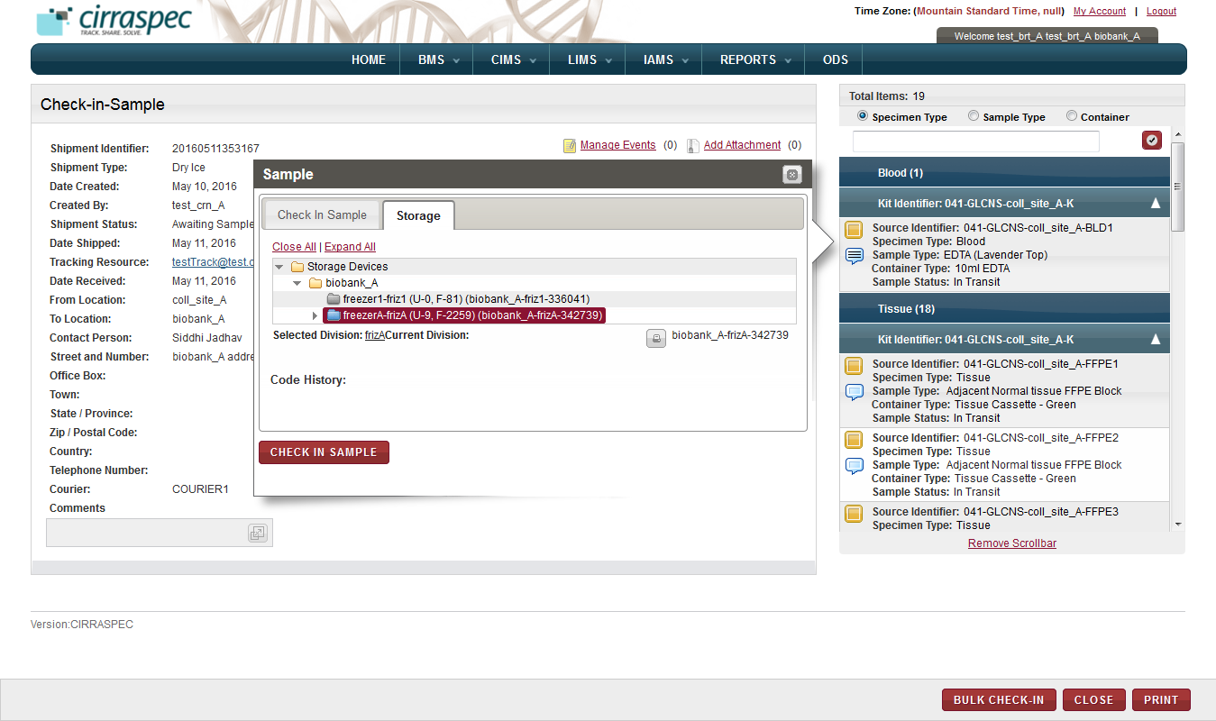

To assign a storage location, perform the following steps:

1. Click the **Expand All** link to expand the **Storage Devices** folder to show all storage devices.
2. Click appropriate storage device name (blue folder) to display all levels of storage within that device.

Note:

* Device not available appears as grey folder
* Device with space available appears as blue folder

1. Click the device level where you want to store the biospecimen.

For example, Freezer X, Shelf 1, Rack 2, and Box 3.  
The storage map appears and displays the used cells and available cells for the selected level.

**Note:**

* Storage Map cells that are available appear in beige or brown color.
* Cells that are used appear in red or rust color.
* The current selection appears in green color.

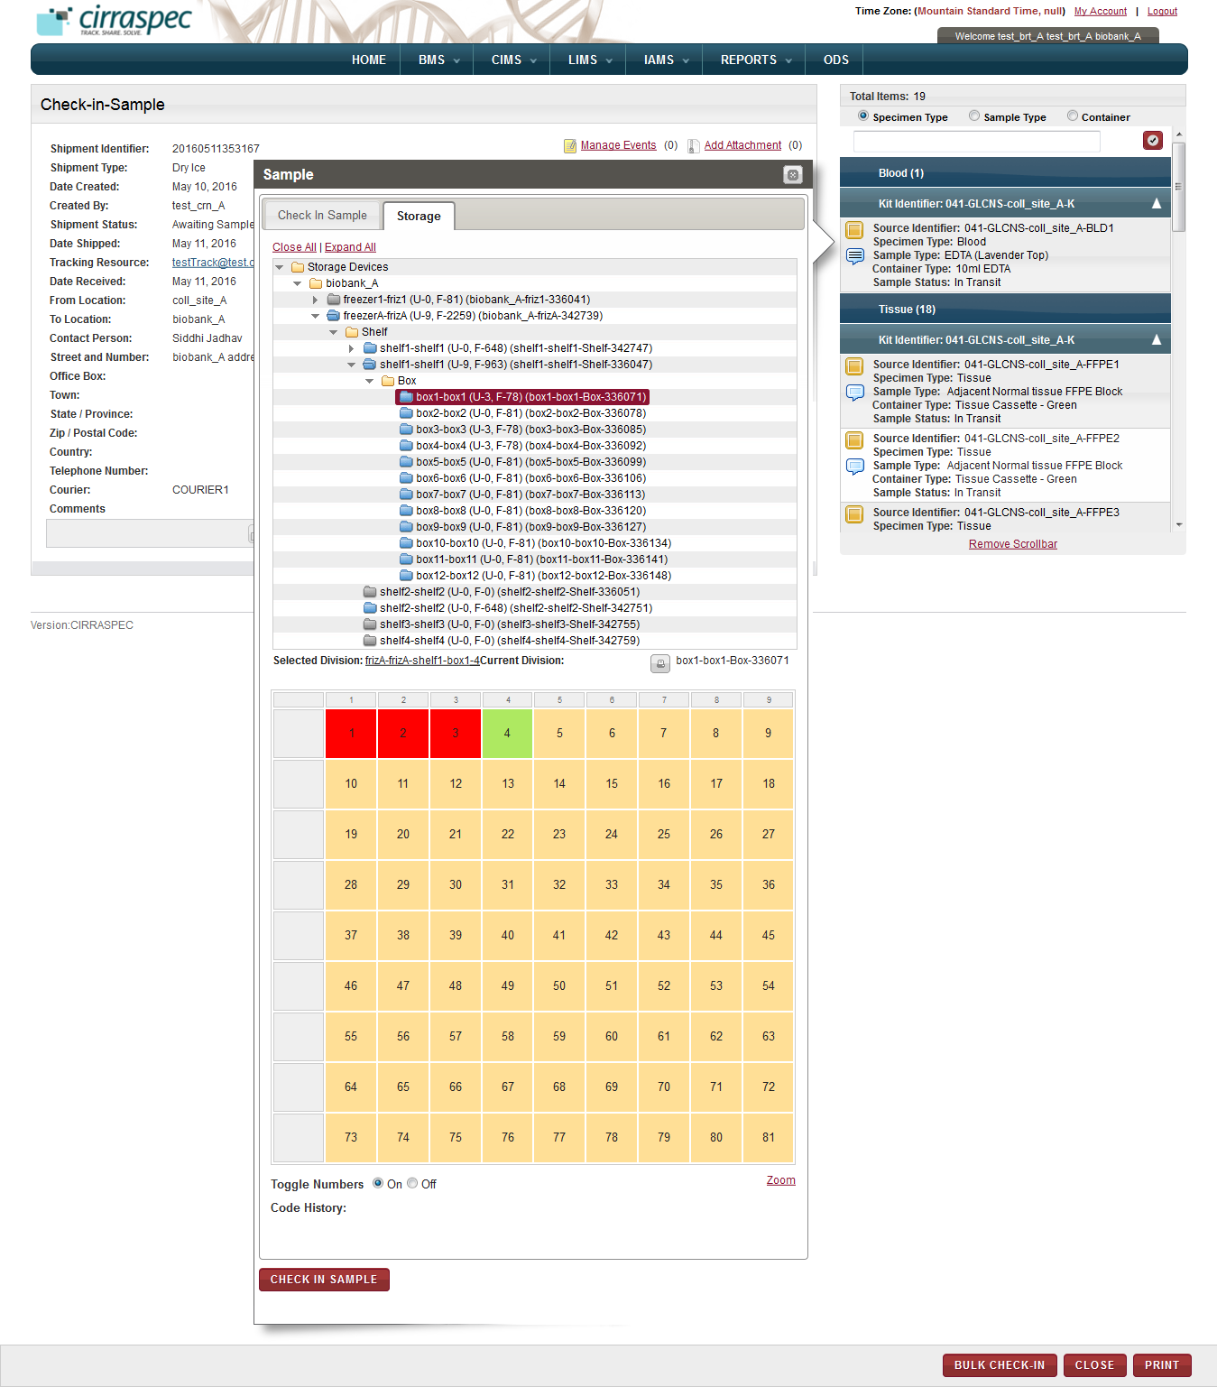

1. Storage map
2. Click the cell where you want to store the biospecimen.

**Note:**

* To view the biospecimens that are stored, move the cursor over the red cells.
* To display or hide numbers in the cells, in the **Toggle Numbers** field, click **Off**.

1. Click **CHECK IN SAMPLE**.

The **Sample** window closes. The biospecimen is checked in. In the shipment cart, a blue check mark appears next to this biospecimen. The Specimen status in the shipment cart is updated to **In Inventory** andstorage location reflects as specified in the **Sample** window.

**Note:**

* The shipment status remains **Awaiting Samples Check-in** until the last biospecimen is checked in.
* After you check in the last biospecimen of a shipment, the status changes to **Completed.**
* To modify a biospecimen that you checked in, click the blue check mark icon, repeat steps 7 to 9, and then click **MODIFY**.
* In sample window, when you modify a current storage location, the previous location changes to gray color and the new selection is set to green color.

### Checking in and Store Biospecimens in Bulk

You can check in all the biospecimens of a shipment as a group and perform several tasks on multiple biospecimens of a shipment.

On the **Bulk Check-In** page, you can perform the following tasks:

* Add an identifier to a shipment biospecimen.
* Perform searches for specific shipment biospecimens.
* Check in multiple shipment biospecimens.
* Generate, view, and print labels for multiple shipment biospecimens.
* Generate a list of multiple shipment biospecimens.

**Note:**

* The shipment must have the **Awaiting Samples Check-in** status.

To access the **Bulk Check-In** page:

1. Log in to the application using your log in credentials.

The home page appears.

1. Point to the arrow of the **BMS** tab, and then click **Shipments**.

The **Shipment Search** page appears.

1. Click **SEARCH**.

The shipment search page displays a list of shipments that are accessible based on your login location.

1. Click the row of the shipment for which you want to check in biospecimens in bulk.

The **View Shipment** page appears.

1. Click **BULK CHECK-IN**.

The **Bulk Check-In** page appears.

1. To search for specific biospecimens in the shipment, enter appropriate information in the **Table Filter Criteria** fields. Following table lists each field and its description.

Table : Performing a searching of biospecimens in the shipment

| **Field** | **Description** |
| --- | --- |
| **Sample Status** | Click the appropriate status for which you want to search. |
| **Specimen Type** | Click the appropriate specimen type for which you want to search. |
| **Container Type** | Click the appropriate container type for which you want to search. |
| **Sample Type** | Click the appropriate sample type for which you want to search. |

1. Click **FILTER**

The biospecimens list at the bottom of the screen displays the search results based on the selections you made above.  
  
For example: If you select **In Inventory** as the Sample Status and **Blood** as the Specimen Type and click **FILTER**, the biospecimens list displays only blood biospecimens with status of **In Inventory** in this shipment.

1. To add a new identifier to a biospecimen:
2. Click on the **Identifier** of the biospecimen for whichyou want to add a new identifier.  
   The **Add Identifier(s)** window is displayed.
3. Click on the add icon add icon.   
   The Source identifier and Identifier Type fields are added to the Add identifier(s) window.
4. In the **Source Identifier** box, type the new identifier.
5. In the **Identifier Type** list, click on the appropriate identifier type.   
   **Note:** The **Identifier Type** list displays the following identifier types:

* **Internal:** For user-assigned identifiers based on lab or site naming or numbering conventions.
* **Kit Content:** For identifying biospecimen content within a kit.
* **Other:** For any other identifier type.

1. Click the check mark icon check mark icon.  
   The new identifier is added to the list of Identifiers in the window.
2. Click **SAVE.**  
   The new identifier replaces the previous identifier on the Bulk Check-in page.
3. To generate a biospecimen list report:
   1. Select the checkboxes of the biospecimens for which you want to generate a report.

**Note:** To generate a report of all the biospecimens in the shipment, select the checkbox on the gray header.

* 1. In the **Actions** list, click **Generate Report**.
  2. Click **INITIATE**.

The report for the biospecimens that you selected appears in a new window.

1. To generate a barcode label for one or more biospecimens:
2. Select the checkboxes of the biospecimens for which you want to generate a barcode label.

**Note:** To generate barcode labels for all the biospecimens, select the checkbox on the gray header.

1. In the **Actions** list, click **Generate Labels**.
2. Click **INITIATE**.

The print barcode window appears.

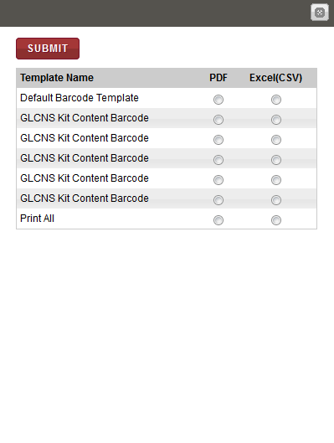

1. To generate a PDF copy of the labels, click **PDF** for the appropriate template type, and then click **SUBMIT**.

The image of the barcode labels that are associated with the biospecimens appear below.

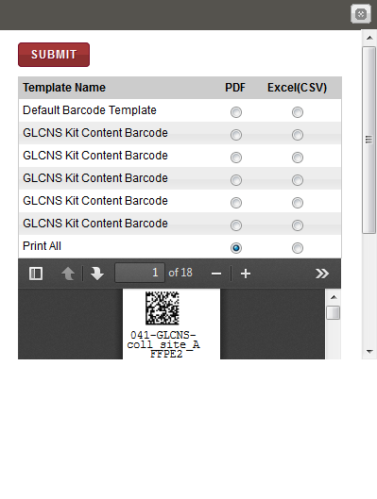

**Note**: To identify tools for viewing multiple labels, printing labels and saving the file to your machine, hover the cursor over the icons in the horizontal and vertical navigation bars.

1. To check in biospecimens:
2. Select the checkboxes of the biospecimens that you want to check in.

**Note:** To check in all the biospecimens, select the checkbox on the gray header.

1. In the **Actions** list, click **Check-In Samples**.
2. Click **INITIATE**.

The **Check-In Samples** window appears.

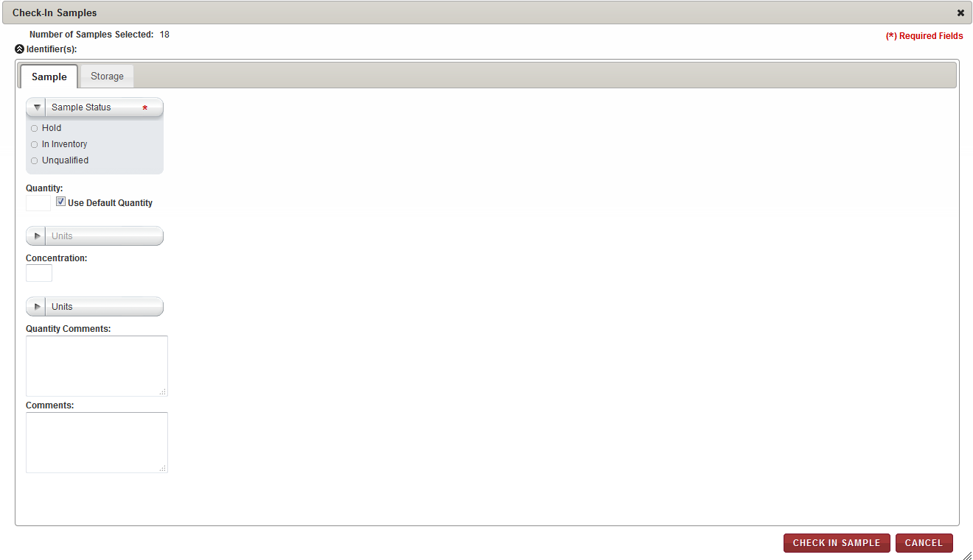

1. On the **Sample** tab, enter appropriate information in each field. Following table lists each field and its description.

Table : Checking in a biospecimen – Sample tab

| **Field** | **Description** |
| --- | --- |
| **Sample Status\*** | Click appropriate status for the biospecimens. |
| **Use Default Quantity** | This checkbox is selected by default. Keep this checkbox selected if you want to use the default quantity that is defined for the Kit Template associated with the biospecimens. **Note:** If checked, the Quantity and Units fields below are disabled and the default values defined in RPMS for this kit item are automatically used. |
| **Quantity** | If not using the Default Quantity, type the quantity of this biospecimen. |
| **Units** | If not using the Default Quantity, click the appropriate unit of measure associated with the Quantity field. |
| **Concentration** | Type the concentration of this biospecimen. |
| **Units** | Click the appropriate unit of measure associated with the Concentration field. |
| **Quantity Comments** | Type comments regarding the quantity, as needed. |
| **Comments** | Type comments regarding the shipment, as needed |

1. To assign a storage location, click the **Storage** tab.  
   The storage assignment fields are displayed.

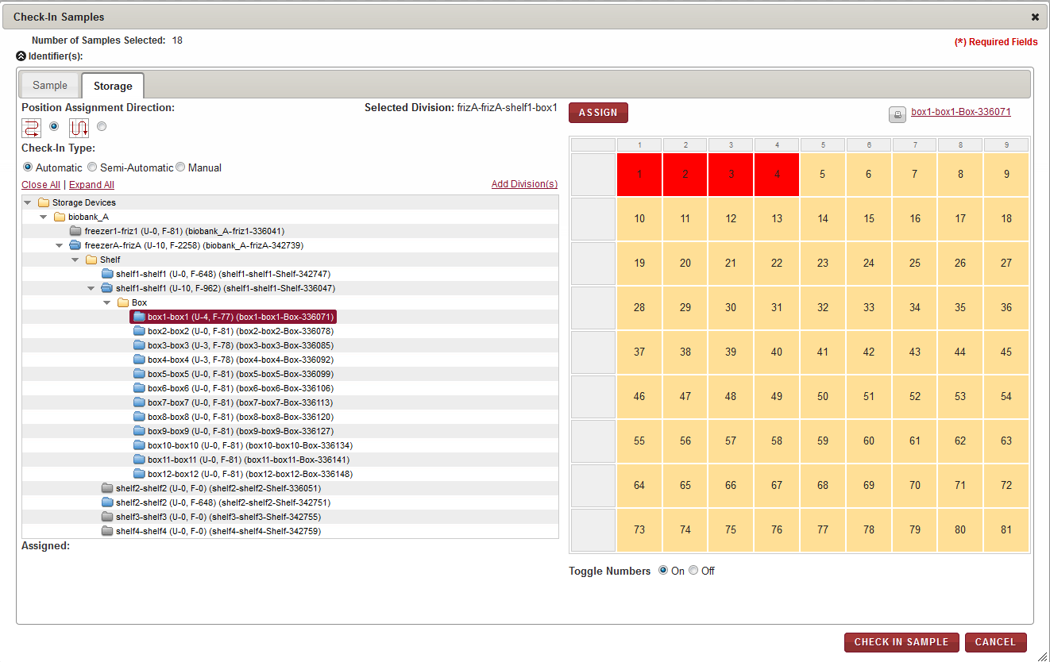

1. Enter appropriate information in each field. Following table lists each field and its description.

Table : Checking in a biospecimen – Storage tab

| **Field** | **Description** |
| --- | --- |
| **Position Assignment Direction** | Click the appropriate direction for assigning a storage location to each of the biospecimens.  **Note:**   * The arrow icon that goes right and left depicts assignment of biospecimens to available cells on the storage map in horizontal rows. * The arrow icon that goes up and down depicts assignment of biospecimens to available cells on the storage map in vertical columns. |
| **Check-In Type** | Click the appropriate means of assigning the storage location:  **Automatic:** The application automatically assigns the biospecimens that you select to available locations in the storage device starting with the first available location.  **Semi-Automatic:** You can select the initial location and assign it to a biospecimen. The application then assigns each biospecimen to the next available location.  **Manual:** You can assign each biospecimen to a location by selecting a cell on the storage map each time. |

1. To select the storage division where you want the biospecimens stored:
2. Click **Expand All** to expand the Storage Devices taxonomy to show all storage devices.
3. Click the appropriate storage device name (blue folder) to display all storage divisions within that device.
4. Click the division where you want to store the biospecimens. For example, Freezer X, Shelf 1, Box 3.  
   The storage map of the cell positions within this division appears on the right.
5. If you selected **Automatic** as **Check-In Type**, click **ASSIGN**.

The application performs the following actions:

* Assigns each biospecimen to the next available location within the selected device.
* Updates the storage map with the new assignments.
* Displays the position assignments in the **Assigned** field at the bottom.

**Note:** If a division does not have enough available positions for all the selected biospecimens, you can select another division and proceed until all biospecimens are assigned.

1. If you selected **Semi-Automatic** as **Check-In Type**, perform the following steps:
2. Click the available cell on the storage map where you want to store the first biospecimen.

**Note:**

* Storage Map positions that are available appear in tan or goldenrod color.
* Positions that are used appear in red or rust color.
* The current selection appears in green color.

The **Assign Identifier** window appears.

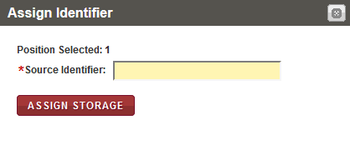

1. In the **Source Identifier** box, scan or type the identifier of the first biospecimen that you want to assign to the selected storage map cell.  
   **Note:** You can display the identifiers of the biospecimens to be assigned by clicking on the arrow icon beside the **Identifiers** field in the top left corner of the **Check-In Samples** window.
2. Click **ASSIGN STORAGE**.

The application performs the following functions:

* Assigns the biospecimen to the cell that you selected and updates the storage map.
* Displays the window again with the **Position Selected** field automatically displaying the next available position.

1. Confirm the assignment of each biospecimen by clicking on **Assign Storage** each time the **Assign Identifier** window appears until all biospecimens are assigned.

**Note:**

* If the container type associated with the specified biospecimen is not valid for this storage location, an error message appears. You can select another division and repeat steps b. - c.
* If the storage division does not have enough available positions for all the biospecimens, you can select another division.

1. If you selected **Manual** as **Check-In Type**, perform the following steps:
2. Click the available cell on the storage map where you want to store the first biospecimen.

**Note:**

* Storage Map positions that are available appear in tan or goldenrod color.
* Positions that are used appear in red or rust color.
* The current selection appears in green color.

The **Assign Identifier** window appears.

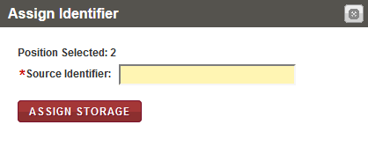

1. In the **Source Identifier** box, scan or type the identifier of the first biospecimen that you want to assign to the selected storage map cell.  
   **Note:** You can display the identifiers of the biospecimens to be assigned by clicking on the arrow icon beside the **Identifiers** field in the top left corner of the **Check-In Samples** window.
2. Click **ASSIGN STORAGE**.

The application assigns the biospecimen to the cell that you selected and updates the storage map.

1. Repeat steps a. – c. until all biospecimens are assigned.

**Note:**

* If the container type associated with the specified biospecimen is not valid for this storage location, an error message appears. You can select another division and repeat steps a. - c.
* If the storage division does not have enough available positions for all the biospecimens, you can select another division.

1. Click **CHECK IN SAMPLE**.

The **Check-In Samples** window closes. These biospecimens, onthe **Bulk Check-In** page appear reflecting the status assigned to them.

Click **CLOSE** button on the **Bulk Check-In** page.

The biospecimens also appear as checked-in with a blue check mark on the **View Shipment** page. The status of the shipment on the **View Shipment** page remains **Awaiting Samples Check-in** until all the biospecimens are checked in. Once all biospecimens are checked in, the status of the shipment changes to **Complete.**

# 



































































# Upload the lab report into the system to the patient enrolled

### Viewing a list of Subjects

To view a list of subjects:

1. Log in to the application using your log in credentials.

The CIRRASPEC home page appears.

1. Point to the arrow of the **CIMS** tab, and then click **Subject Centric View**.

The **Subject Search** page appears.

1. Click **SEARCH**.

Thesubject search page displays a list of subjects.

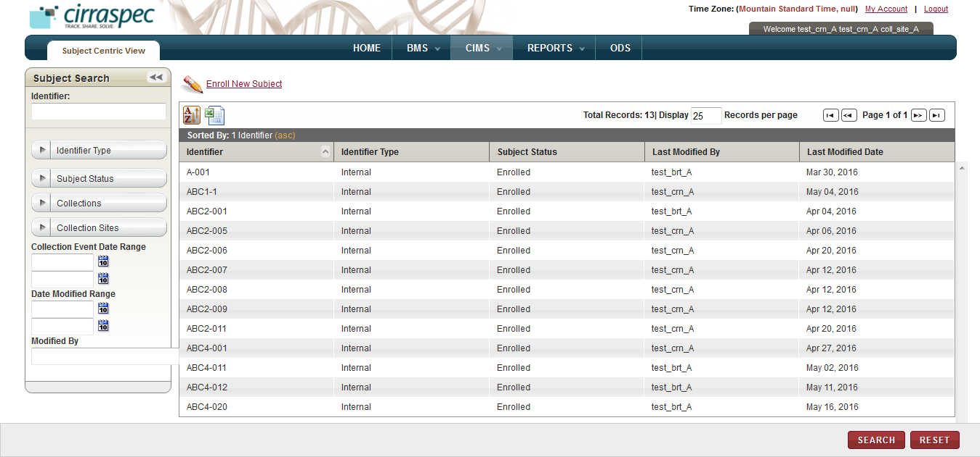

### Searching for a Subject

To search for a specific subject or a group of subjects:

1. Point to the arrow of the **CIMS** tab, and then click **Subject Centric View**.

The **Subject Search** page appears.

1. Click **SEARCH**.

The **Subject Search** page displays the **Subject Search** pane.

Arrow hides/displays the Subject Search pane



1. Specify your search criteria by completing one or more fields in the **Subject Search** pane.

**Note:**

* You can use one field or a combination of fields to search for subjects.
* You can type the full or partial value in a search field along with an asterisk (*) before or after the partial value. For example, if you type **02\***, you obtain records that begin with 02. If you type **\*02**, you obtain records that end with 02.

Following table lists each search field and its description.

Table : Subject Search fields

| **Field** | **Description** |
| --- | --- |
| **Identifier** | Type identifier of the subject you want to search for. |
| **Identifier Type** | Click appropriate type to search for subjects with that type of Identifier.  **Note:** To search for subjects associated with all types, click **All**. |
| **Subject Status** | Click appropriate status to search for subjects with this subject status.  **Note:** To search for subjects associated with all statuses, click **All**. |
| **Collections** | Click appropriate Collection to search for subjects associated with this Collection.  **Note:** To search for subjects associated with all Collections, click **All**. |
| **Collection Sites** | Click appropriate Site to search for subjects associated with this Collection Site  **Note:** To search for subjects associated with all Collection Sites, click **All**. |
| **Collection Event Date Range** | Click the date icon and then in the pop-up, select appropriate date option to search for Collection Events scheduled in this timeframe.  For more information, see **Understanding the Date Range Options** |
| **Date Modified Range** | Click the date icon and then in the pop-up, select appropriate date option to search for subjects modified in this timeframe.  For more information, see **Understanding the Date Range Options** |
| **Modified By** | Type log in ID of the user to search for subjects modified by that user. |

1. Click **SEARCH**.  
   The search results appear.   
     
   **Note:** Click the header of the column with which you want to sort the results. For more information about how to sort the search results, see **Sorting Search Results**

### Viewing the Subject Details

To view the details of a subject:

1. Log in to the application using your log in credentials.

The CIRRASPEC home page appears.

1. Point to the arrow of the **CIMS** tab, and then click **Subject Centric View**.

The subject search page appears.

1. Click **SEARCH**.

The **Subject Search** page displays a list of subjects.

1. Click the row of the subject for which you want to view the details.

The **Subject View** page appears with the details of the subject you selected.

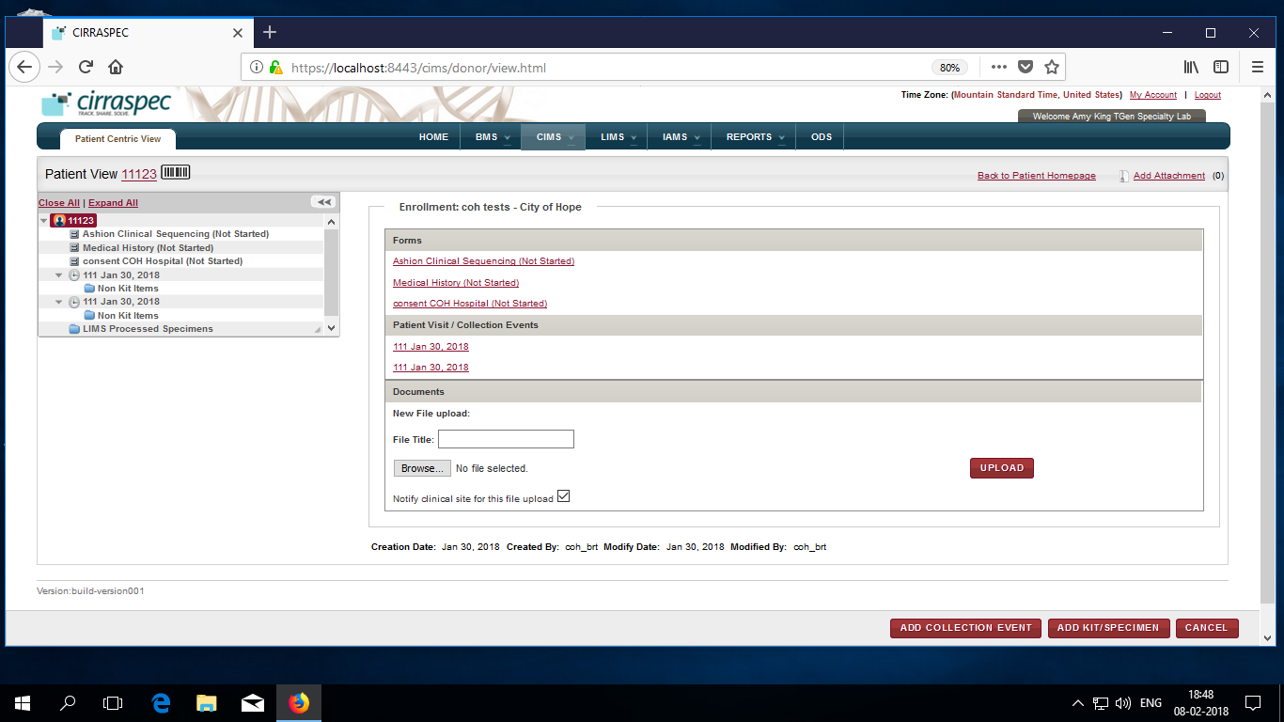

**Note:**

* You can expand the subject hierarchy tree displayed on the left by clicking on the **Expand All** link, or by clicking on the arrow icon 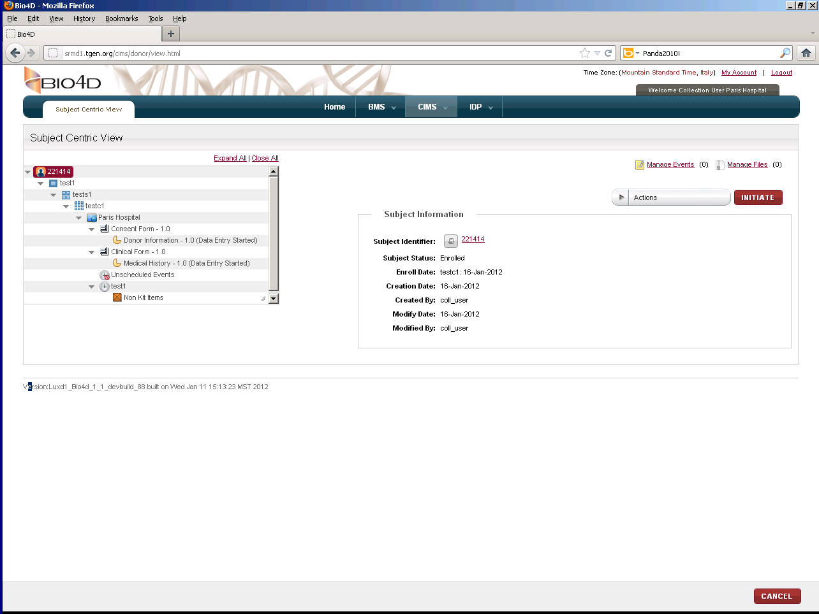for the level you want to expand.
* You can click on the various hierarchy tree levels on the left side of the page, to display information for the selected level.  
  For example, if you click on the Collection level, information for this Collection appears on the right side of the page. If you click on a form level, information for this form appears on the right side of the page.

OR

You can click on the links provided on the right side of the page, to display information for various different levels.

For example, if you click on a **Visit** link under the **Subject Visit / Collection Events** section (which in turn is under the **Enrollment** section), the **View Collection Event** page is displayed on the right side.

If you click on a form section link under the **Forms** section (which in turn is under the **Enrollment** section), the form section appears on the right side of the page.

**Note**: To go back to the homepage with links, click the **Back to Subject Homepage** link towards the center-upper side of the page.







### Upload patient test report into the system

Once you receive the patient test report, To upload onto the patient follow below steps :

1. Log in to the application using your log in credentials.

The **CIRRASPEC** **home** page appears.

1. Point to the arrow of the **CIMS** tab, and then click **Subject Centric View**.

The **Subject Search** page appears.

1. Click **SEARCH**.

Thesubject search page displays a list of subjects.

1. Click the row of the subject for which you want to view the collection event details.

The **Subject View** page appears.

On the right pane, **Forms, Patient Visits, Documents** sections appear.

1. On the Documents section, Click **Browse**…

**Popup** to choose file for upload appears.

1. On the pop-up, Locate the path of file, Select the file and Click **Open**.

Filename appears on the screen as seen below

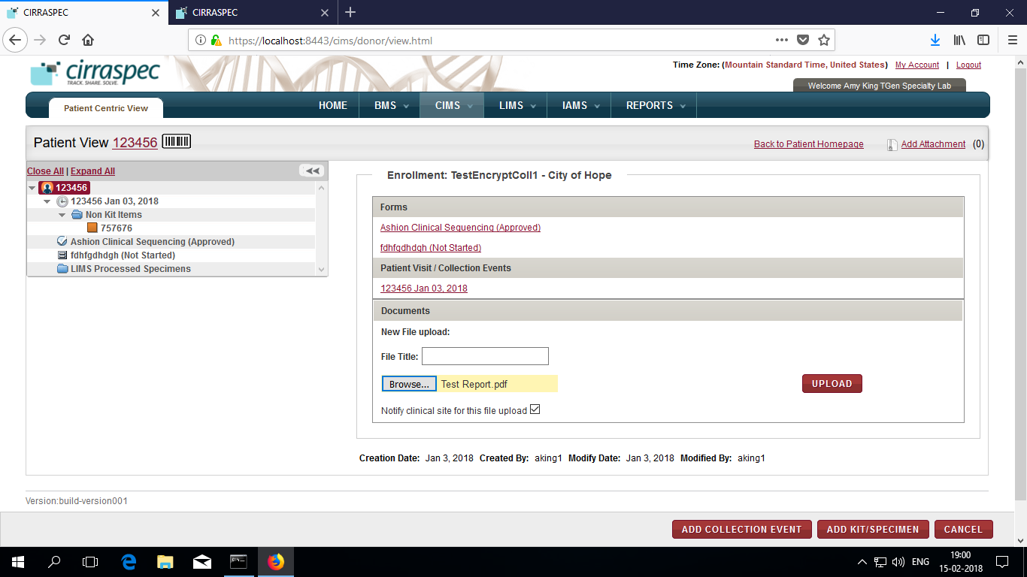

1. ( Optional ) Enter **File Title** in text box

Filename on upload will be as entered in this field .

If not entered, filename will be as the name of file uploaded.

1. Select **Notify clinical site for this file upload** checkbox**.**
2. Click **UPLOAD**
   1. The file gets uploaded and appears as link in Documents section.

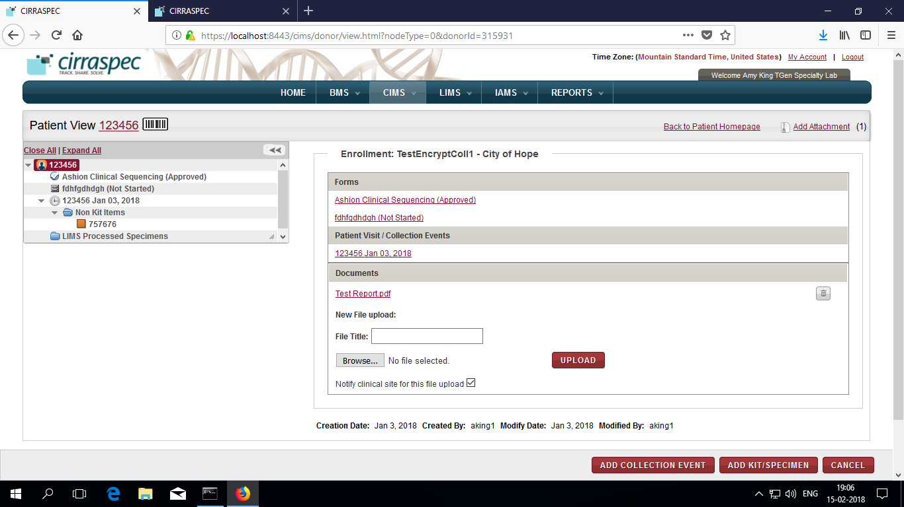

* 1. An email notification is sent to the Clinical Site to inform that patient lab report is ready for review.

1. If in case you require to Delete Report in any circumstances, click **Delete icon** alongside the report llink you see on Documents section.

*Alternative Path:*

1. On Home Page, click on “Search Patients” link.

The **Subject Search** page appears.

Follow same steps as above from step3 to find the patient and upload his test report.















































































# Understand Search Options and Search Results Display Options

## Search by Date Ranges

You can search for information using the date range options in the search pane.

To understand the date range options:

1. Log in to the application using your log in credentials.

The home page appears.

1. Point to the arrow of the **BMS** tab, and then click the module (Kits Inventory, Kits Shipment, for which you want to access the search pane.

The search pane for the module that you selected appears on the left side of the page.

1. To specify the date range, click the date icon Search calendar for the **Date Range** box.

A list of date range options appears.

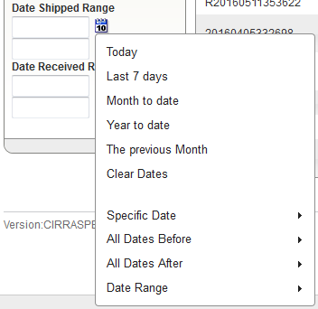

1. Click the appropriate daterange option. Following table lists each range option and its description.

Table : Date range options

| **Option** | **Description** |
| --- | --- |
| **Today** | To search for information for the current day, click this option. |
| **Last 7 days** | To search for information for the last seven days, click this option. |
| **Month to date** | To search for information from the start date of the current month to the current date, click this option. |
| **Year to date** | To search for information from the start date of the current year to the current date, click this option. |
| **The previous Month** | To search for information for the previous month, click this option. |
| **Clear Dates** | To clear the information in the **Date Range** box, click this option. |
| **Specific Date** | To search for information for a specific date:   1. Click this option.   The **Specific Date** calendar appears.  **Note:**   * The calendar displays the current month and year. To update the month, click the arrow icons next to the month name. * To update the year, in the year list, click the appropriate year.  1. Click the appropriate date, and then click **Done**.   The date appears in the **Date Range** box. |
| **All Dates Before** | To search for information on all dates before a specific date:   1. Click this option.   The **All Dates Before** calendar appears.  **Note:**   * The calendar displays the current month and year. To update the month, click the arrow icons next to the month name. * To update the year, in the year list, click the appropriate year.  1. Click the appropriate date, and then click **Done**.   The date appears in the **Date Range** box. |
| **All Dates After** | To search for information from a specific date to the current date:   1. Click this option.   The **All Dates After** calendar appears.  **Note:**   * The calendar displays the current month and year. To update the month, click the arrow icons next to the month name. * To update the year, in the year list, click the appropriate year.  1. Click the appropriate date, and then click **Done**.   The date appears in the **Date Range** box. |
| **Date Range** | To search for information within a specific date range:   1. Click this option.   The **Start date** and **End date** calendars appear.  **Note:**   * The calendars display the current month and year. To update the month, click the arrow icons next to the month name. * To update the year, in the year list, click the appropriate year.  1. In the **Start date** calendar, click the start date of the date range. 2. In the **End date** calendar, click the end date of the date range. 3. Click **Done**.   The dates appear in the **Date Range** box. |

### 

## Change Search Results display

### Changing the Number of Records Per Page

You can specify the number of records that are displayed on each page of the search results.

To specify the number of records displayed on a page:

1. Log in to the application using your log in credentials.

The home page appears.

1. Point to the arrow of the **BMS** tab, and then click the module for which you want to access the search pane.   
   The search pane for the module that you selected appears on the left side of the page.
2. Click **SEARCH**.   
   A list of items within the module that you selected appears.
3. Enter appropriate number of records you want to display in the **Display** **Records per page**

Box.  
The specified number of records is displayed on the search results page.

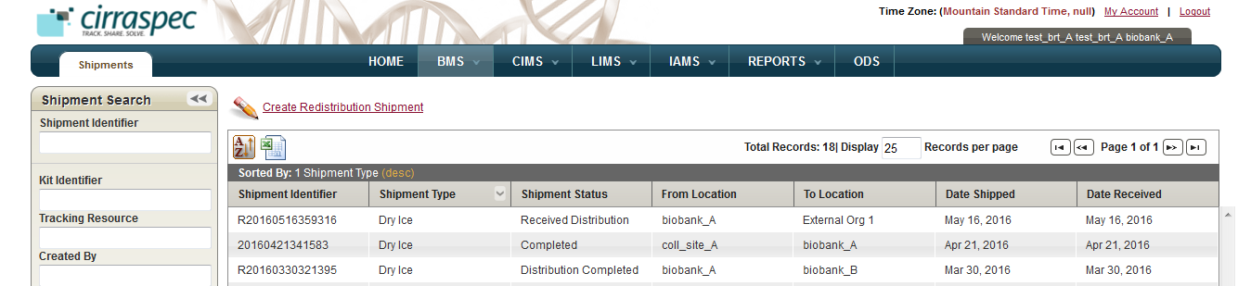

### Changing the Display Columns

You can change the search results display columns.

To change the display columns:

1. Log in to the application using your log in credentials.

The home page appears.

1. Point to the arrow of the **BMS** tab, and then click the module for which you want to access the search pane.   
   The search pane for the module that you selected appears on the left side of the page.
2. Click **SEARCH**.   
   A list of items within the module that you selected appears.
3. Click the **Sort Table** button Sort Table button.

The sort window appears and displays the Column Visibility check boxes.

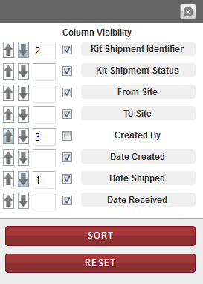

1. If you want to hide a column in the search results, de-select the checkbox for that column.   
   The search results appear without the specified column.   
     
   If you want to display a column in the search results, select the checkbox for that column.  
   The search results appear without the specified Colum.   
   **Note:** To clear all the selections, click **RESET**.

### Sorting Search Results

You can sort your search results in ascending and descending order based on one column or based on multiple columns.

To sort the search results based on one item:

1. Log in to the application using your log in credentials.

The home page appears.

1. Point to the arrow of the **BMS** tab, and then click the module for which you want to access the search pane.   
   The search pane for the module that you selected appears on the left side of the page.
2. Click **SEARCH**.   
   A list of items within the module that you selected appears.
3. Click the column item name by which you want to sort.   
   The search results are sorted according to the column that you selected.   
     
   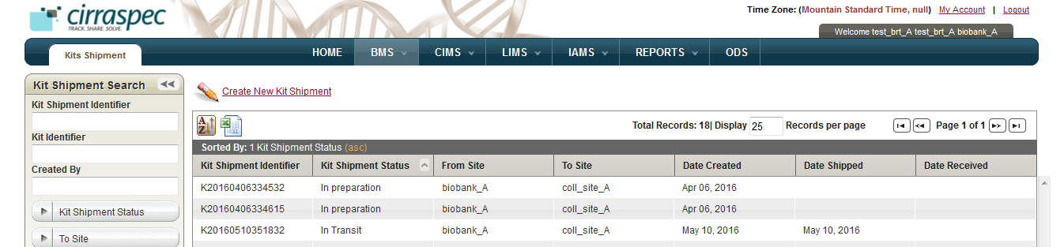

To sort the search results based on multiple items:

1. Log in to the application using your log in credentials.

The home page appears.

1. Point to the arrow of the **BMS** tab, and then click the module for which you want to access the search pane.   
   The search pane for the module that you selected appears on the left side of the page.
2. Click **SEARCH**.   
   A list of items within the module that you selected appears.
3. Click the **Sort Table** button Sort Table button.

The sort window appears and displays the sort options.



1. If you want to sort the search results in ascending order, click the **Sort Ascending** button Sort Ascending button next to the appropriate item column.

If you want to sort the search results in descending order, click the **Sort Descending** button Sort Descending button next to the appropriate item column.

1. To set the sorting priority of an item column, type the appropriate number in the box next to the item column that you want to prioritize.

For example, in the following figure, you sort the search results in descending order first by Date Shipped, then by Kit Shipment Identifier and then in ascending order by Created By:

* **Date Shipped** to **1** in **descending** order
* **Kit Shipment Identifier** to **2** in **descending** order
* **Created By** to **3** in **ascending** order



1. Click **SORT**.

The search results are sorted according to the sort order that you specified.

**Note:** To clear all the selections, click **RESET**.



















































### 